Joy Brentwood AGRA
Artist
Jandi Studio rhyll
www.jandistudiorhyll.com
30 Beach Rd.
Rhyll Vic 3923
Australia
bbrentwo@bigpond.net.au
Phone 0412 097 644
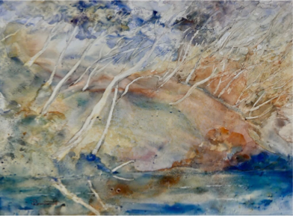

Joy Brentwood AGRA
Artist’s Statement

I am a long-standing member of both the Australian Guild of Realist Artists and the Pastel Society of Victoria. On moving to Phillip Island, I joined the Artists Society of Phillip Island (ASPI), with whom I regularly exhibit. I am a life member of ArtSpace Wonthaggi.

I taught watercolour painting for a number of years and was involved in organising several exhibitions for my students. I was commissioned by Whitehorse City Council to design commemorative Australia Day envelopes for three successive years. My curatorial experience includes working for several years as weekend Gallery Manager at AGRA Galleries in Camberwell, Victoria.

In 2013 I was awarded signatory membership of the Australian Guild of Realist Artists, in recognition of a consistently high standard of exhibited art, and allowing the use of the title AGRA after my name.

In the Australian Art Excellence Award exhibition in 2018 I was awarded the Kath Ballard Watercolour prize for the best watercolour, as well as the Packing Room prize, for my painting ‘Spirits of the Chasm’ (Watercolour on Yupo).

Recent exhibitions and significant awards:
- ‘Round About, The Circle Show’, Gecko Gallery, Fish Creek 2019 – invited participant.
- Phillip Island and San Remo Rotary Art Show 2019, Best Watercolour under $1000.
- ‘Synergy’ – joint exhibition with Ian Pascoe, Meeniyan Art Gallery, Meeniyan, 3-29 April 2019.
- Australian Art Excellence Award 2018, Nov 2018, AGRA Galleries, Camberwell, Kath Ballard Award for Best Watercolour.
- Australian Art Excellence Awards Exhibition, 2017, AGRA Galleries, finalist.
- Runner-up, AGRA Autumn Seasonal Exhibition, August 2017.
- “Pigment and Pen”, joint exhibition with Ian Pascoe, Quadrant Gallery, Hawthorn www.quadrantgallery.com.au, 6-29 August 2015.

