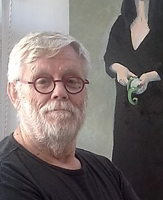

John Mutsaers
John has been a full-time professional artist since 1983. So far he has held 38 solo exhibitions including a successful London exhibition in 2006 and a group exhibition with selected artists for the Australian Trade Commission in Shanghai in 2008.
His next major exhibition of 12 Paintings, 12 Drawings and a sculpture will open at ArtSpace gallery Wonthaggi on Sunday, 23 February 2020, at 4pm. The Infinite Birdcage has it its core the theme of the right to freedom for every person. In parallel there is a writers’ competition. See website for more information www.johnmutsaers.com
John is represented in public, corporate, and private collections around the world, including The Nederlands, England, Ireland, USA, China, Canada and Australia.
Collectors include:
The late, HRH Princess Margaret, UK,
Brigadier General Charles Duke, USA
(Astronaut, Moon walker- Apollo 16)
Lisa Gerrard, Australia (Composer)
La Trobe Regional Gallery, Morwell, Vic., Australia
Bega Regional Gallery, Bega, NSW, Australia
Shanghai Electric Power Company, China
Returned and Services League, Australia
LaTrobe City, Vic., Australia
Australian Paper Mills
John was born in Eindhoven, The Netherlands, in 1942 and comes from generations of artists on both sides of his family. He arrived in Melbourne in 1956.
Although he mainly paints John also loves to sculpt and his first international success was a sculpture based on C J Dennis’ poem, “The Sentimental Bloke,” which, was sold in New York in 1994.
His large stone and steel sculptures, “Forks in Spuds,” were a featured solo exhibition for two months in six locations around Federation Square and on the banks of the Yarra River in Melbourne in 2008. The sculptures were part of an artistic response to the United Nations’ call for an end to world hunger. They are now permanently placed along the Princess Highway near Trafalgar, Victoria, Australia.

